CSS Text related important tips

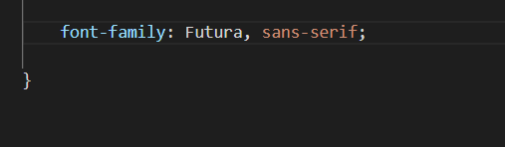

Here we have used more than one font family property.

Well we can use more also

It is because if the user’s computer is not compactible with futura than any default sans serif font of that system gets loaded

This adding more than one font is known as **font stacks**

[**https://www.cssfontstack.com/**](https://www.cssfontstack.com/)is a rally cool site that tells us which fonts are mostly used in systems, so for less used fonts we can always mentioin more than one font, making a font stack

We don’t need to know about the font stack

We can copy whole font stack from this site

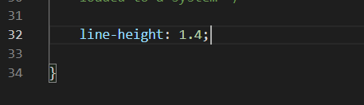

This is also really important to present the text in the web

Instead of in pixels give values in numbers

Where

1 = line height is same as font size

And we can manage rest as per need and looks

Doing this the line height will auto adjust itself as per the font size

**Using google fonts nicely**

We can select multiple styles of same fonts of different versions. Each time we add a new style our link to be embedded gets updated and finally we will get a nice link to embed.

Normally font-weight:400; is default for paragraph to read

**One common mistake**

Let say we have not pick the style of 100 weight while embedding the link from google font, and in our site if we use

Font-weight:100; it’s not gonna work.

Since we never embedded 100 weight style of font